Figure 2 – Terms of trade for products from agriculture, forestry and fishery with European Union 28
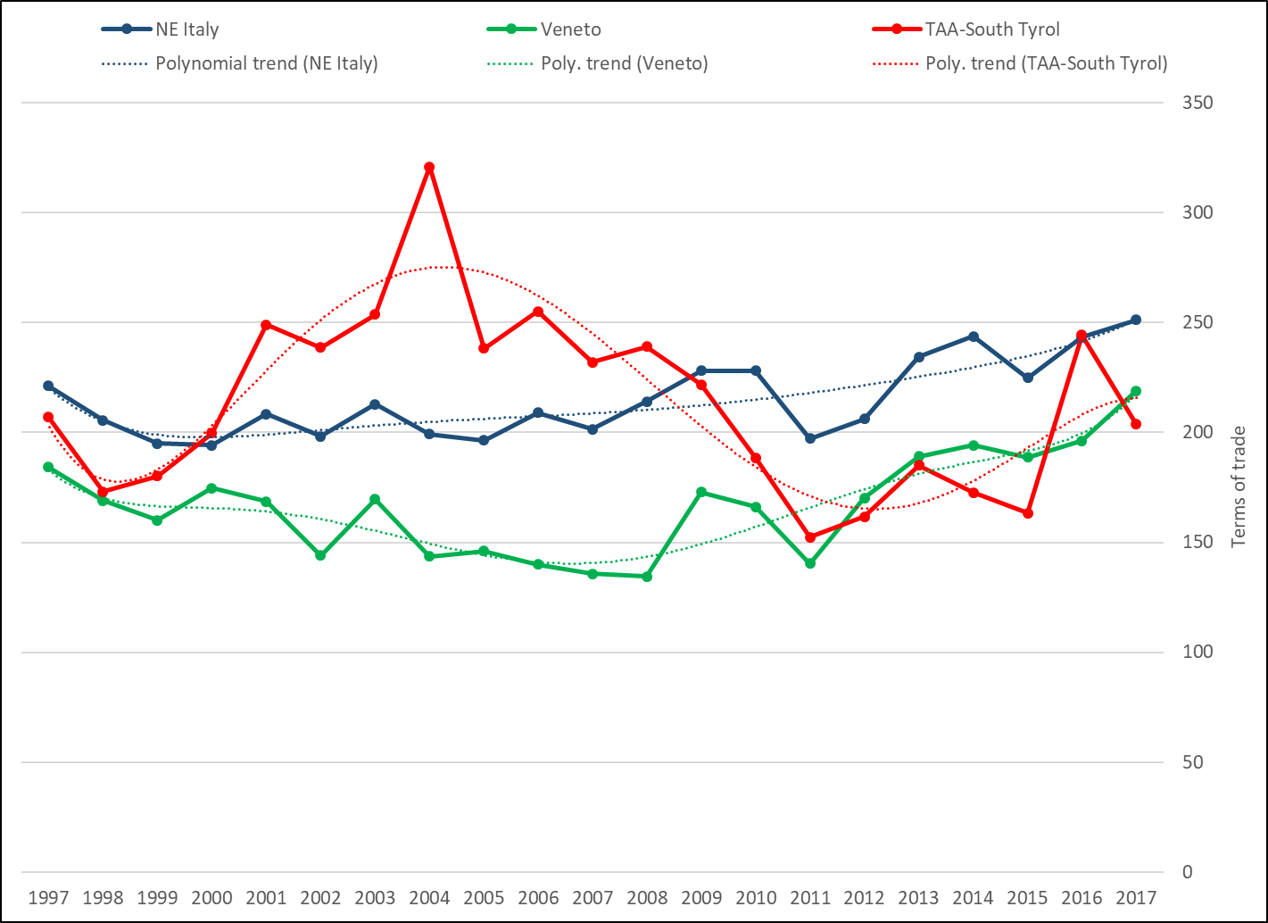
Source: elaborations on data from ISTAT (2018). Provisional figures for 2017.

