Figure 1 – Timber sector balance of trade (Export-Import) of the timber sector with European Union 28
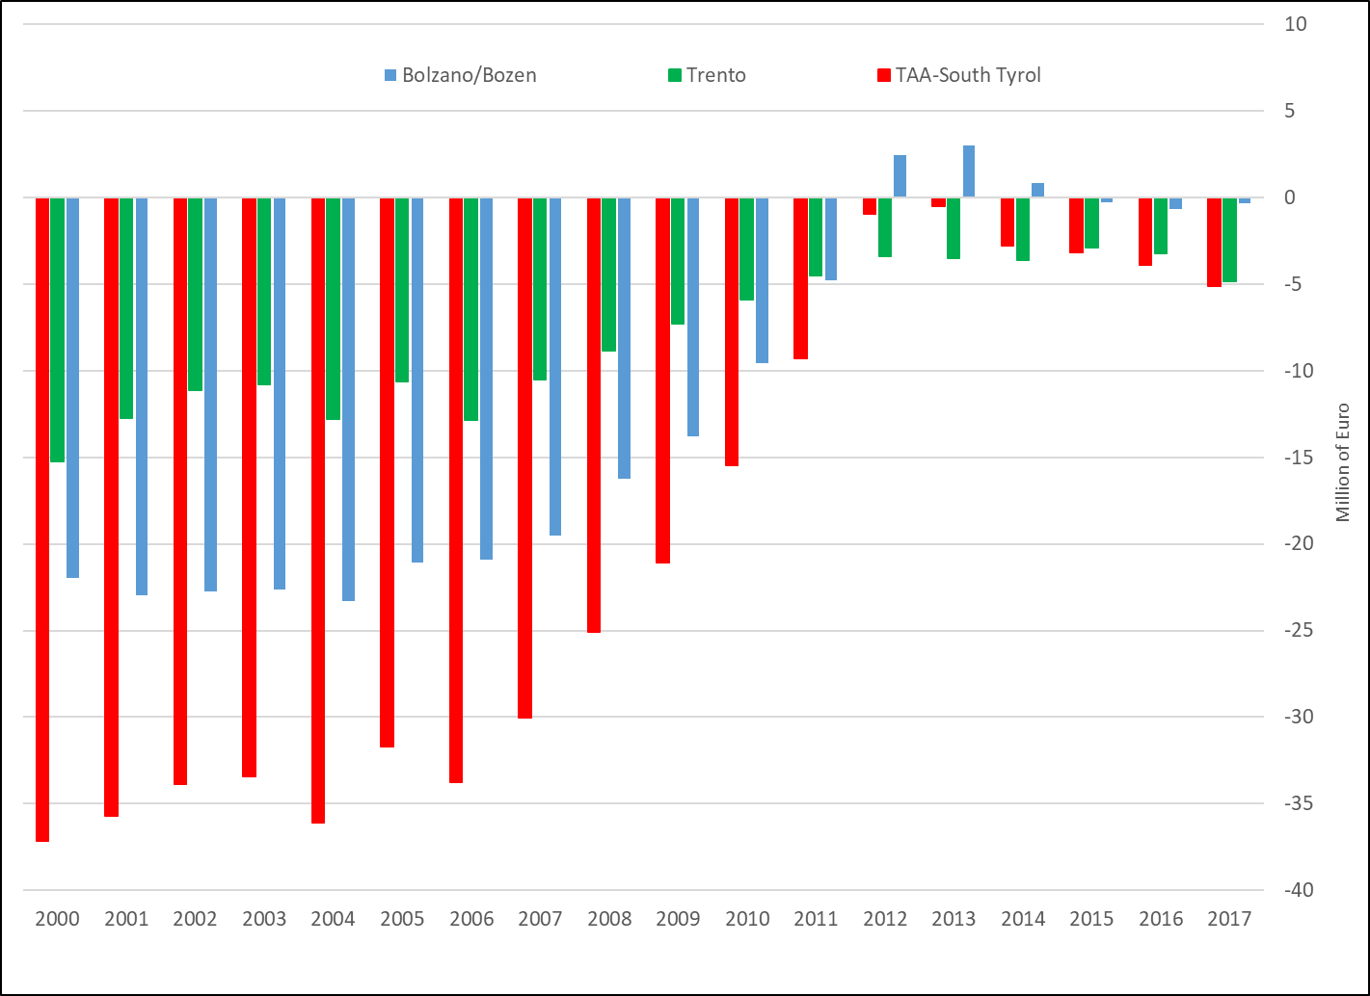
Source: elaborations on data from ISTAT, Ateco AA022 (2018). Provisional figures for 2017.

